Paint System Fault Reporting
Blips & Stream Statistics Generation
You cannot accumulate statistics from the blobs on the fly and just store the overall counts if you want to be able to say, give me stats for the last hour (8hours, 24hours) from now, as now is constantly changing. This means you have to store 24 hours worth of blob data and regenerate the stats from the data every time you post the results.

In order to reduce both processing and development time, I have produced 2 views of the faults.
- Record faults according to there size distribution in one of four categories: small, medium, large, and very large.
- Record faults in terms of there position across the curtain where the curtain is divided into 16 regions (~200mm per region).This assumes the operator needs to know roughly which area they are in so he can clear the fault.

The faults are aggregated together in time into separate counters based on size category (1) and zone position (2), with a interval in minutes that is configurable with a minimum value of 1 minute.

The blip statistics will be recorded as a count for each zone and for each size category, whereas stream statistics will be accumulated on the basis of their duration in seconds for each zone.

Blips & Stream Digital outputs
The digital outputs are straight forward i.e. if there is a blob in the current image, turn the output on for 0.5s. If the output is already on then you already registered the presence of a blob so don’t do anything.
If it is a stream (i.e. it touches the both the top and bottom of the image) then turn the stream output on whilst a stream is present. No distinction is possible between thinning and streams.

Rolling Map
I have utilised a XY plot to create a rolling map of Faults based on there distribution across the zones. The map displays the last hour and scrolls in intervals of one minute.

OPC Stats
The following stats are available via OPC

OPC Tage Name Description

Blips.All CountLastHour INT count of all blips for last hour
Blips.Small CountLastHour INT count of small blips for last hour
Blips.Medium CountLastHour INT count of medium blips for last hour
Blips.Large CountLastHour INT count of large blips for last hour
Blips.XLarge CountLastHour INT count of Xlarge blips for last hour
Blips.All CountLast8Hour INT count of all blips for last 8hours
Blips.All CountLast24Hour INT count of all blips for last 24hours

Streams.All SecondsLastHour INT seconds of all streams for last 8hours
Streams.Small SecondsLastHour INT seconds of small streams for last hour
Streams.Medium SecondsLastHour INT seconds of medium streams for last hour
Streams.Large SecondsLastHour INT seconds of large streams for last hour
Streams.XLarge SecondsLastHour INT seconds of Xlarge streams for last hour
Streams.All SecondsLast8Hour INT seconds of all streams for last 8hours
Streams.All SecondsLast24Hour INT seconds of all streams for last 24hours

Results Panel Screenshot
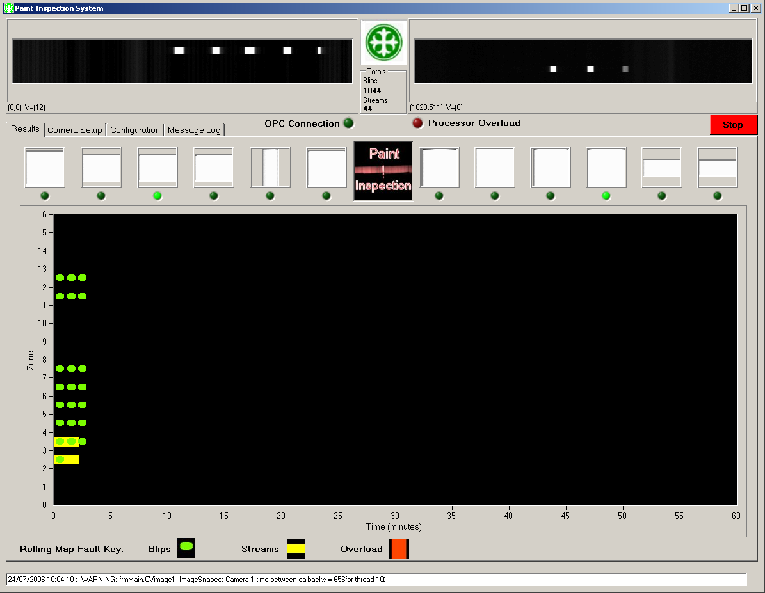

OPC Tags Screenshot
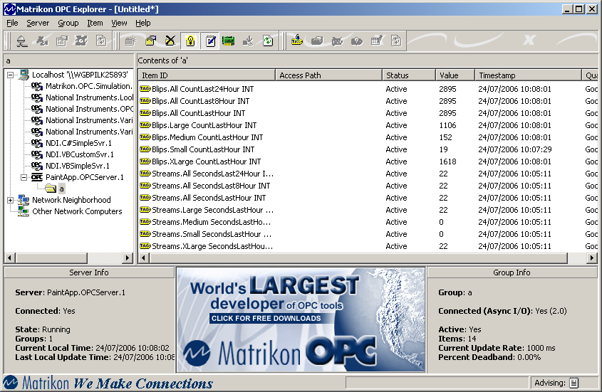

Camera Setup Screenshot
